14

13

Scroll down to view the second source

The American Student, #2



Proven Study Techniques

*By*

Michael Grandelli and Zelda McEvoy

12

Placeholder Text Placeholder Text Placeholder Text Placeholder Text Placeholder Text Placeholder Text Placeholder Text Placeholder Text Placeholder Text Placeholder Text Placeholder Text Placeholder Text Placeholder Text Placeholder Text Placeholder Text Placeholder Text Placeholder Text Placeholder Text Placeholder Text Placeholder Text Placeholder Text Placeholder Text Placeholder Text Placeholder Text Placeholder Text Placeholder Text Placeholder Text Placeholder Text Placeholder Text Placeholder Text Placeholder Text Placeholder Text Placeholder Text



February 2015 #2

The Mid-Term

Exam

EXATRAVAGANZA

!!!

Proven Study Techniques:

Our top staff writers walk you through the techniques that boost grades

The American

Student

Study Spaces Ranked:

Where is the best place to review?

PLUS:

Flashcards, study schedules, and other tools to help prepare



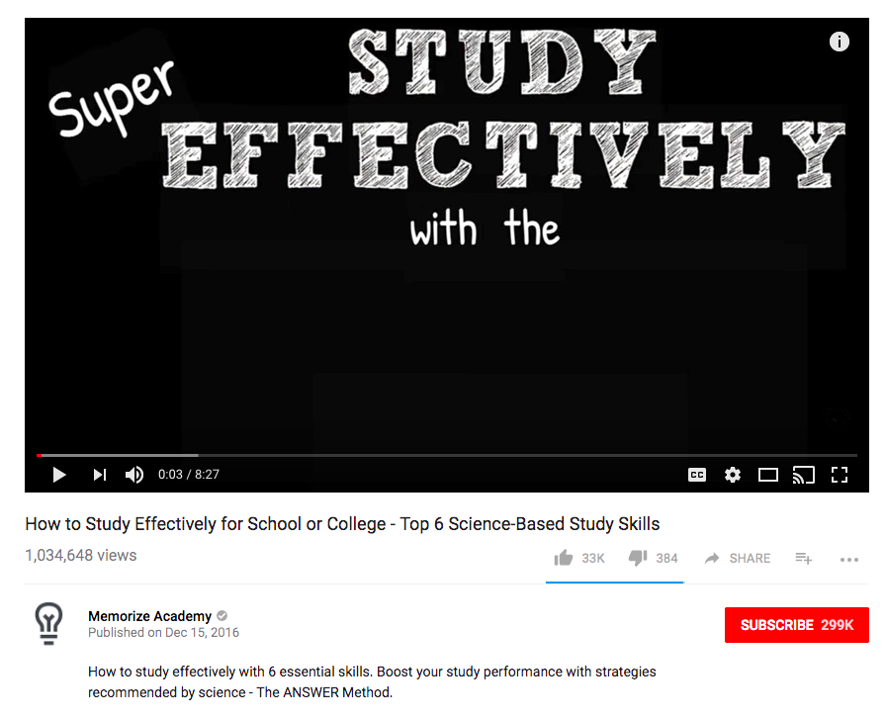

Studying for Tests: Don’t Cram

With

Thomas Lynch



Studying for Tests: Don’t Cram

ProfTom

Published: March 8, 2016

Learn the dos and don’ts of study preparation!